Application & Deployment

1. Open the following github repository <https://github.com/ZeroToHero-2017/JavaDocs/tree/master/Servlets/Day1> and copy the content to your forked github repository.
2. Go to the file location where you have copied the sources and open the project from the Code/servlet-app folder.
3. Complete TODO lines inside HelloWorldServlet.java file.
4. Complete TODO lines inside web.xml file.
5. Run maven clean install
6. Run maven tomcat7:deploy-only under the tomcat plugin

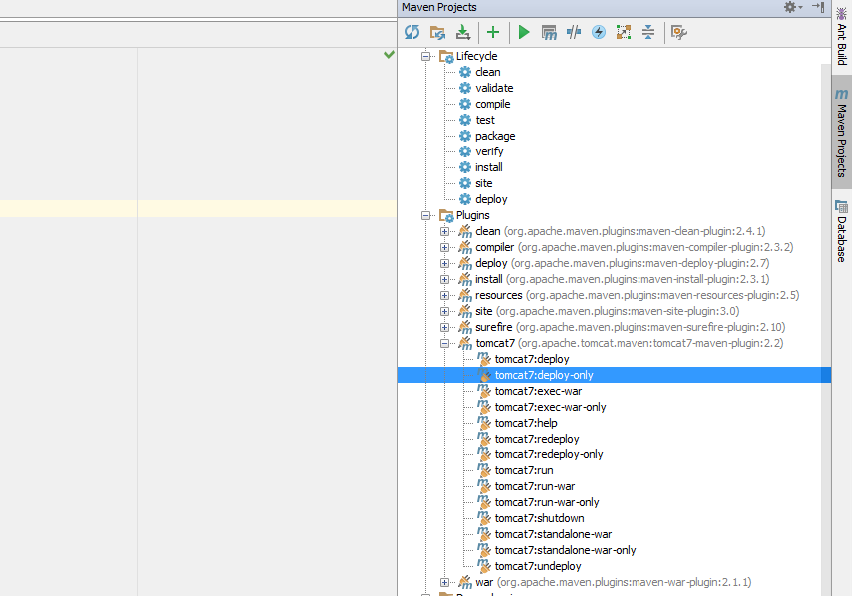

1. If you use tomcat locally as a maven plugin, run tomcat7-run under tomcat7 plugin.

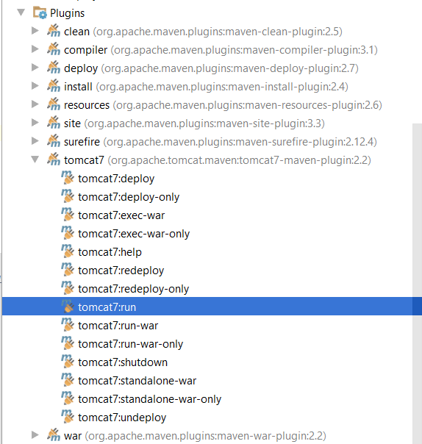

1. Open browser and insert <http://docker.local:49100/servlet-app/> url

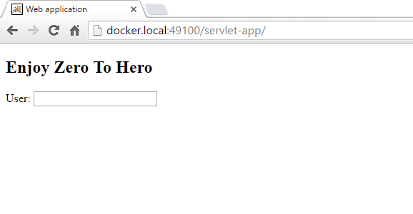

1. Insert some text into “User” input press enter and wait for server response

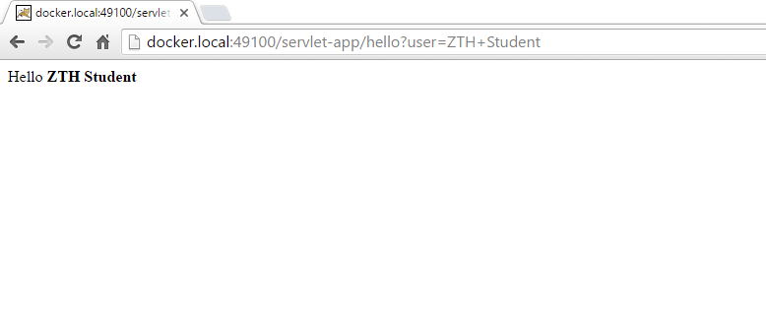

1. To update the web application deployed on the Docker tomcat container follow these stepts:
   1. Change the line “<h2>Enjoy Zero To Hero</h2>” from the index.html to

<h2>I am enjoying zero to hero</h2>

* 1. Run mvn clean install
  2. Run maven tomcat7:undeploy under the tomcat plugin
  3. Run maven tomcat7:deploy-only under the tomcat plugin
  4. Check to see if the web page has updated

